
Nursing Faculty & Provider Summit
March 31 & April 1, 2010
Where: Wichita Marriott Hotel, 9100 Corporate Hills Drive,
Wichita, KS
1-800-610-0673 or 316-651-0333
The purpose of this very important summit is to tie together the findings and input gained from the last two summits, and lay the groundwork for a strategic plan regarding nursing faculty and clinical access in Kansas. The first summit had participants look at what some other states are doing, share some innovative ideas, and respond to a series of guided questions. The second summit, born as an outcome of the first, provided the perspectives of clinical practice regarding clinical education access and related issues. This third, and final summit, will bring together education and practice, so together these partners can lay the foundations for a strategic plan.

We are again requesting attendees consist of nursing program deans or directors, and one significant other faculty member from education; and a representative from the clinical practice side that is involved with nursing education from a provider standpoint.

This summit is funded through grants provided by KBOR and KHA. Meals, breaks and lodging will be covered.
Please contact Don Richards drichards@ksbor.org or Cara Greve cgreve@kha-net.org for more funding details.

The registration form below must be completed for each attendee and sent by fax (785-296-3957), e-mail pgreene@ksbor.org or mail to: Pam Greene, Kansas Board of Regents, Career & Technical Education, 1000 SW Jackson, Suite 520, Topeka, KS 66612, by Friday, March 6, 2010. You may make your hotel reservation by calling the Wichita Marriott Hotel at 316-651-0333 and mention that you are part of the Nursing Education Conference room block.

Registration is from 11:30 AM —12:45 PM, March 31, 2010. The workshop begins at 1:00 PM, March 31, and will end at 3:30, on Thursday, April 1.

Name Position Title

Clinical Education Provider:

Address:
E-Mail Work Phone:
Sponsored by:
KBOR, KHA & KSBN

PN561.04.2009.2605
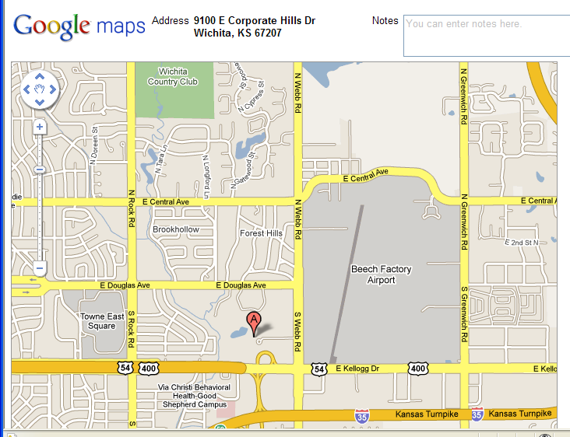

Marriott Hotel Wichita

