FY 2015 LOCAL APPLICATION FOR POSTSECONDARY
PERKINS PROGRAM IMPROVEMENT FUNDS

Part I (a)

Institution Name

Postsecondary Funding: I understand that if funds become unavailable, this application may be terminated. If satisfactory progress and documentation are not made regarding the intended outcomes of the application, this application becomes null and void and all funds must be returned. I further understand that supplanting of funds is not allowed under the Carl D. Perkins Career and Technical Education Act of 2006.

Contact Persons for
 | Name & Position | Telephone & Fax | Email Address
Perkins Grant Application and Progress Reports

CTE Issues

Authorized Administrator—Original Signature Date

STATE USE ONLY—DO NOT WRITE BELOW THIS LINE

$_____________________ (1) Academic and Technical Skill Activities
$_____________________ (2) Articulation/Postsecondary Linkages Activities
$_____________________ (3) All Aspects of an Industry/Work-based Learning Activities
$_____________________ (4) Use of Technology Activities
$_____________________ (5) Professional Development Activities
$_____________________ (6) Program Evaluation Activities
$_____________________ (7) Improve, Expand, Modernize Programs Activities
$_____________________ (8) Size, Scope, Quality Activities
$_____________________ (9) Special Populations Activities
$____________________ (10) Administrative Costs
$_____________________ Total

KBOR Authorized Representative Date
Part I (b)
State of Kansas
Department of Administration
DA-146a (Rev. 06-12)
CONTRACTUAL PROVISIONS ATTACHMENT

Important: This form contains mandatory contract provisions and must be attached to or incorporated in all copies of any contractual agreement. If it is attached to the vendor/contractor's standard contract form, then that form must be altered to contain the following provision:

"The Provisions found in Contractual Provisions Attachment (Form DA-146a, Rev. 06-12), which is attached hereto, are hereby incorporated in this contract and made a part thereof."

The parties agree that the following provisions are hereby incorporated into the contract to which it is attached and made a part thereof, said contract being the _____ day of ____________________, 20_____.

1. Terms Herein Controlling Provisions: It is expressly agreed that the terms of each and every provision in this attachment shall prevail and control over the terms of any other conflicting provision in any other document relating to and a part of the contract in which this attachment is incorporated. Any terms that conflict or could be interpreted to conflict with this attachment are nullified.

2. Kansas Law and Venue: This contract shall be subject to, governed by, and construed according to the laws of the State of Kansas, and jurisdiction and venue of any suit in connection with this contract shall reside only in courts located in the State of Kansas.

3. Termination Due To Lack Of Funding Appropriation: If, in the judgment of the Director of Accounts and Reports, Department of Administration, sufficient funds are not appropriated to continue the function performed in this agreement and for the payment of the charges hereunder, State may terminate this agreement at the end of its current fiscal year. State agrees to give written notice of termination to contractor at least 30 days prior to the end of its current fiscal year, and shall give such notice for a greater period prior to the end of such fiscal year as may be provided in this contract, except that such notice shall not be required prior to 90 days before the end of such fiscal year. Contractor shall have the right, at the end of such fiscal year, to take possession of any equipment provided State under the contract. State will pay to the contractor all regular contractual payments incurred through the end of such fiscal year, plus contractual charges incidental to the return of any such equipment. Upon termination of the agreement by State, title to any such equipment shall revert to contractor at the end of the State's current fiscal year. The termination of the contract pursuant to this paragraph shall not cause any penalty to be charged to the agency or the contractor.

4. Disclaimer Of Liability: No provision of this contract will be given effect that attempts to require the State of Kansas or its agencies to defend, hold harmless, or indemnify any contractor or third party for any acts or omissions. The liability of the State of Kansas is defined under the Kansas Tort Claims Act (K.S.A. 75-6101 et seq.).

5. Anti-Discrimination Clause: The contractor agrees: (a) to comply with the Kansas Act Against Discrimination (K.S.A. 44-1001 et seq.) and the Kansas Age Discrimination in Employment Act (K.S.A. 44-1111 et seq.) and the applicable provisions of the Americans With Disabilities Act (42 U.S.C. 12101 et seq.) (ADA) and to not discriminate against any person because of race, religion, color, sex, disability, national origin or ancestry, or age in the admission or access to, or treatment or employment in, its programs or activities; (b) to include in all solicitations or advertisements for employees, the phrase "equal opportunity employer"; (c) to comply with the reporting requirements set out at K.S.A. 44-1031 and K.S.A. 44-1116; (d) to include those provisions in every subcontract or purchase order so that they are binding upon such subcontractor or vendor; (e) that a failure to comply with the reporting requirements of (c) above or if the contractor is found guilty of any violation of such acts by the Kansas Human Rights Commission, such violation shall constitute a breach of contract and the contract may be cancelled, terminated or suspended, in whole or in part, by the contracting state agency or the Kansas Department of Administration; (f) if it is determined that the contractor has violated applicable provisions of ADA, such violation shall constitute a breach of contract and the contract may be cancelled, terminated or suspended, in whole or in part, by the contracting state agency or the Kansas Department of Administration.

Contractor agrees to comply with all applicable state and federal anti-discrimination laws.

The provisions of this paragraph number 5 (with the exception of those provisions relating to the ADA) are not applicable to a contractor who employs fewer than four employees during the term of such contract or whose contracts with the contracting State agency cumulatively total $5,000 or less during the fiscal year of such agency.

6. Acceptance Of Contract: This contract shall not be considered accepted, approved or otherwise effective until the statutorily required approvals and certifications have been given.

7. Arbitration, Damages, Warranties: Notwithstanding any language to the contrary, no interpretation of this contract shall find that the State or its agencies have agreed to binding arbitration, or the payment of damages or penalties. Further, the State of Kansas and its agencies do not agree to pay attorney fees, costs, or late payment charges beyond those available under the Kansas Prompt Payment Act (K.S.A. 75-6403), and no provision will be given effect that attempts to exclude, modify, disclaim or otherwise attempt to limit any damages available to the State of Kansas or its agencies at law, including but not limited to the implied warranties of merchantability and fitness for a particular purpose.

8. Representative's Authority To Contract: By signing this contract, the representative of the contractor thereby represents that such person is duly authorized by the contractor to execute this contract on behalf of the contractor and that the contractor agrees to be bound by the provisions thereof.

9. Responsibility For Taxes: The State of Kansas and its agencies shall not be responsible for, nor indemnify a contractor for, any federal, state or local taxes which may be imposed or levied upon the subject matter of this contract.

10. Insurance: The State of Kansas and its agencies shall not be required to purchase any insurance against loss or damage to property or any other subject matter relating to this contract, nor shall this contract require them to establish a "self-insurance" fund to protect against any such loss or damage. Subject to the provisions of the Kansas Tort Claims Act (K.S.A. 75-6101 et seq.), the contractor shall bear the risk of any loss or damage to any property in which the contractor holds title.

11. Information: No provision of this contract shall be construed as limiting the Legislative Division of Post Audit from having access to information pursuant to K.S.A. 46-1101 et seq.

12. The Eleventh Amendment: "The Eleventh Amendment is an inherent and incumbent protection with the State of Kansas and need not be reserved, but prudence requires the State to reiterate that nothing related to this contract shall be deemed a waiver of the Eleventh Amendment."

13. Campaign Contributions / Lobbying: Funds provided through a grant award or contract shall not be given or received in exchange for the making of a campaign contribution. No part of the funds provided through this contract shall be used to influence or attempt to influence an officer or employee of any State of Kansas agency or a member of the Legislature regarding any pending legislation or the awarding, extension, continuation, renewal, amendment or modification of any government contract, grant, loan, or cooperative agreement.

Part I (c)

LOCAL ASSURANCES

We, as an eligible recipient for funds under the Carl D. Perkins Career and Technical Education
Act of 2006, hereby grant the following assurances:

- To administer each program, service or activity covered in this application in accordance with all applicable statutes and regulations governing the Carl D. Perkins Career and Technical Education Act of 2006, and

- No funds expended under the Act will be used to acquire equipment (including computer software) in any instance in which such acquisition results in a direct financial benefit to any organization representing the interests of the acquiring entity or the employees of the acquiring entity, or any affiliate of such an organization.

- Certifies by its representative’s signature hereon that neither it nor vendors used in expenditures with Carl D. Perkins grant funds are presently debarred, suspended, proposed for disbarment, declared ineligible, or voluntarily excluded from participation in this Agreement by any federal or state department or agency.

- To comply with all reporting requirements in a timely manner and that the information reported is valid, reliable and accurate.

- To be in compliance with Executive Order 12246; Title VI of the Civil rights Act of 1964, as amended; Title IX Regulations; Section 504 of the Rehabilitation Act of 1973, as amended; Individuals with Disabilities Education Act and any other federal or state laws, regulations and policies which apply to the operation of the programs.

We will not discriminate on the basis of sex, race, color, national origin or disability in the educational programs, services or activities being provided.

_____________________________________________________________________________________________________
Name of Institution

assures the Kansas Board of Regents its’ intent to comply with these Local Assurances as outlined in this document. Further, we are willing to explain, in writing, how we intend to comply with each of these assurances.

Original Signature of Authorized Administrator Title

Date_____________________
Part I (d)

KANSAS BOARD OF REGENTS

TRANSFER OF POSTSECONDARY IMPROVEMENT FUNDS

Use this form for transferring P.L. 109-270 Carl D. Perkins Career and Technical Education Act of 2006 postsecondary funds from one eligible recipient to another eligible recipient providing service on behalf of the institution. Submit an original copy for each institution transferring funds into a consortium/partnership.

I certify that

Institution Name

is transferring all of postsecondary improvement funds made available under Carl D. Perkins Career and Technical Education Act of 2006 for fiscal year 2014 to

Institution Name

The funds will be used as described in the program improvement grant application package of the transferring institution.

________________________________ ______________________________
Original Signature of Authorized Original Signature of Authorized
Administrator Transferring Funds Administrator Receiving Funds

Date____________________________ Date__________________________

**************************

STATE USE ONLY
***************************

I hereby certify that the transferring institution is eligible for the funds identified above and the receiving institution is eligible to receive said funds.

_________________________________________ Date___________________________
Signature of KBOR Authorized Representative

Part I (e)

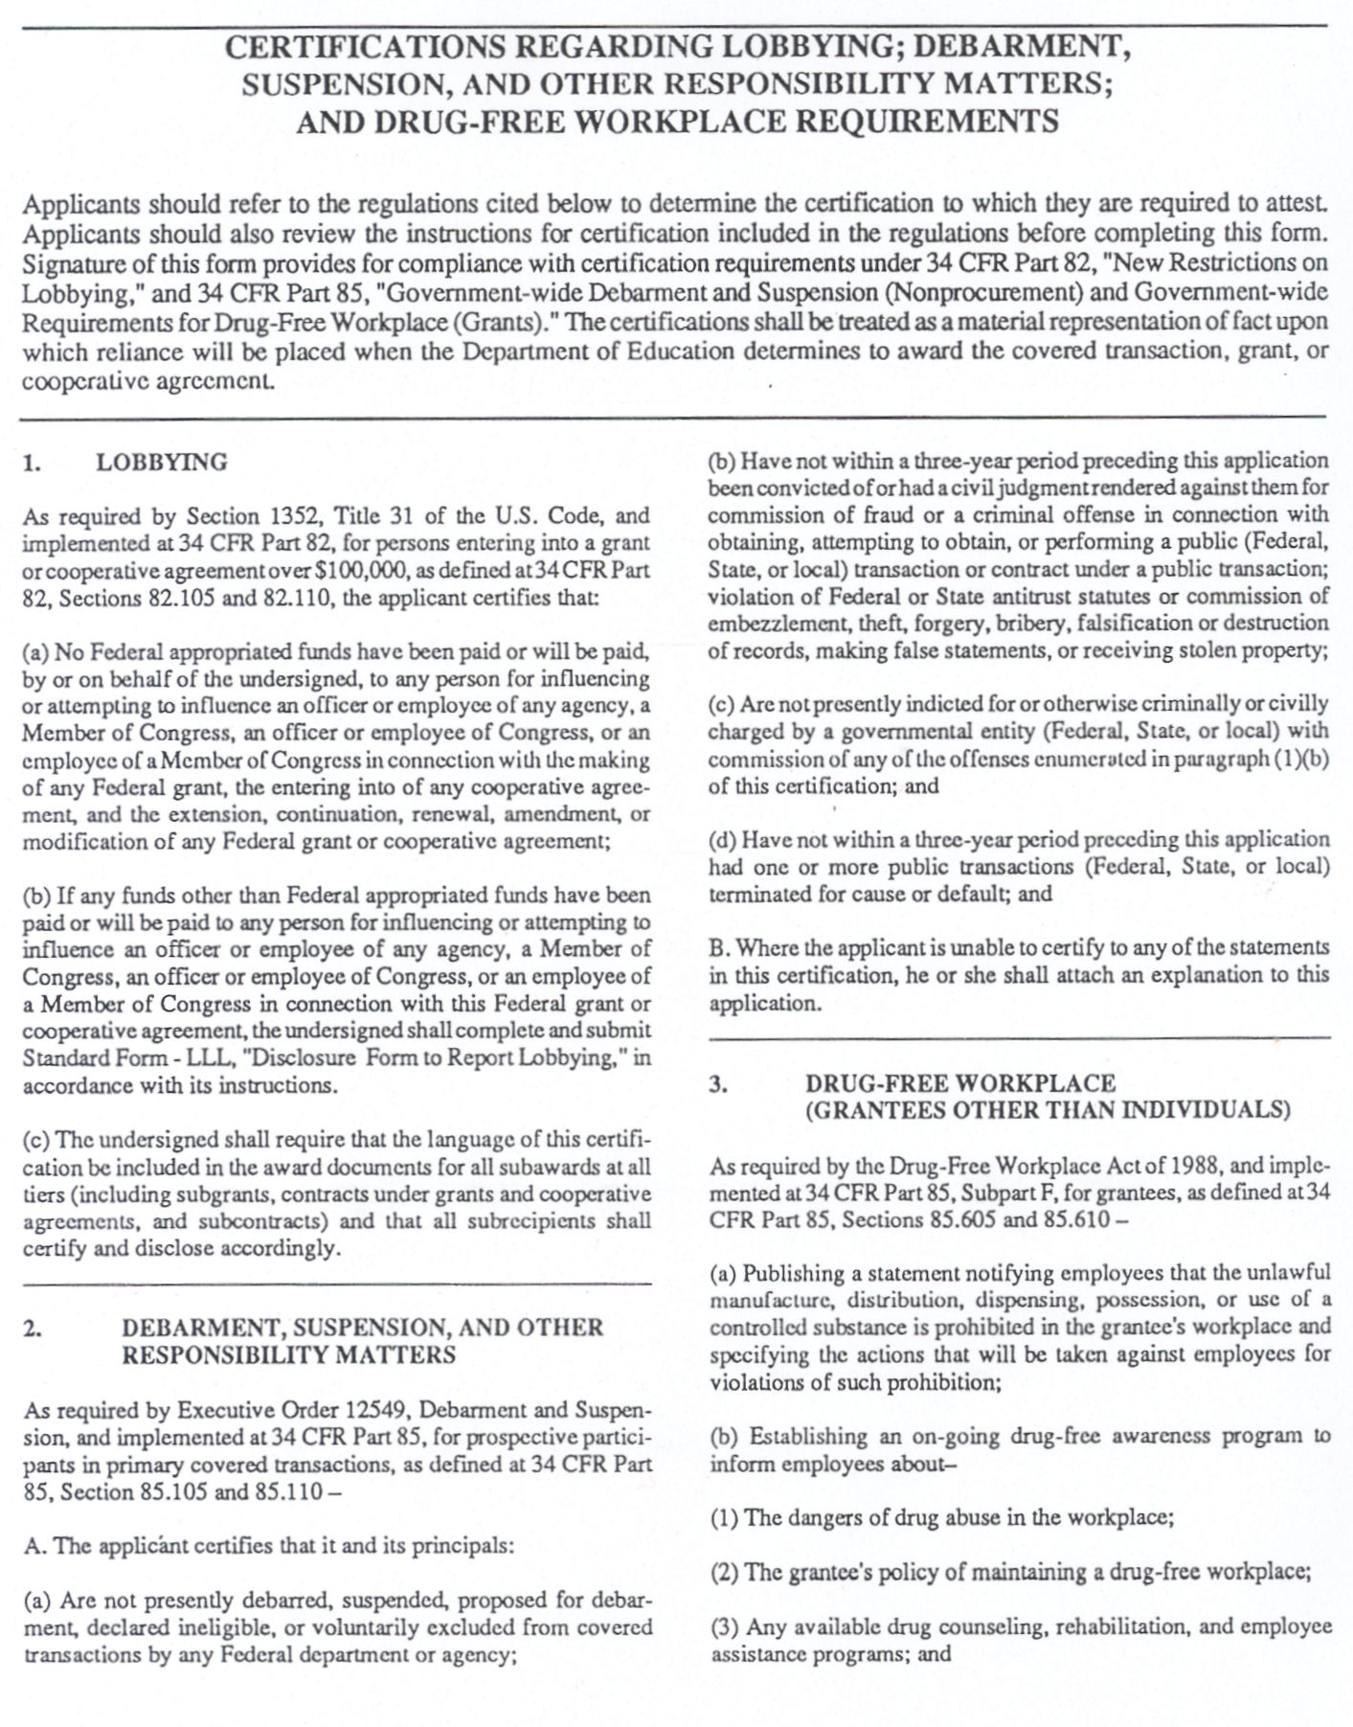

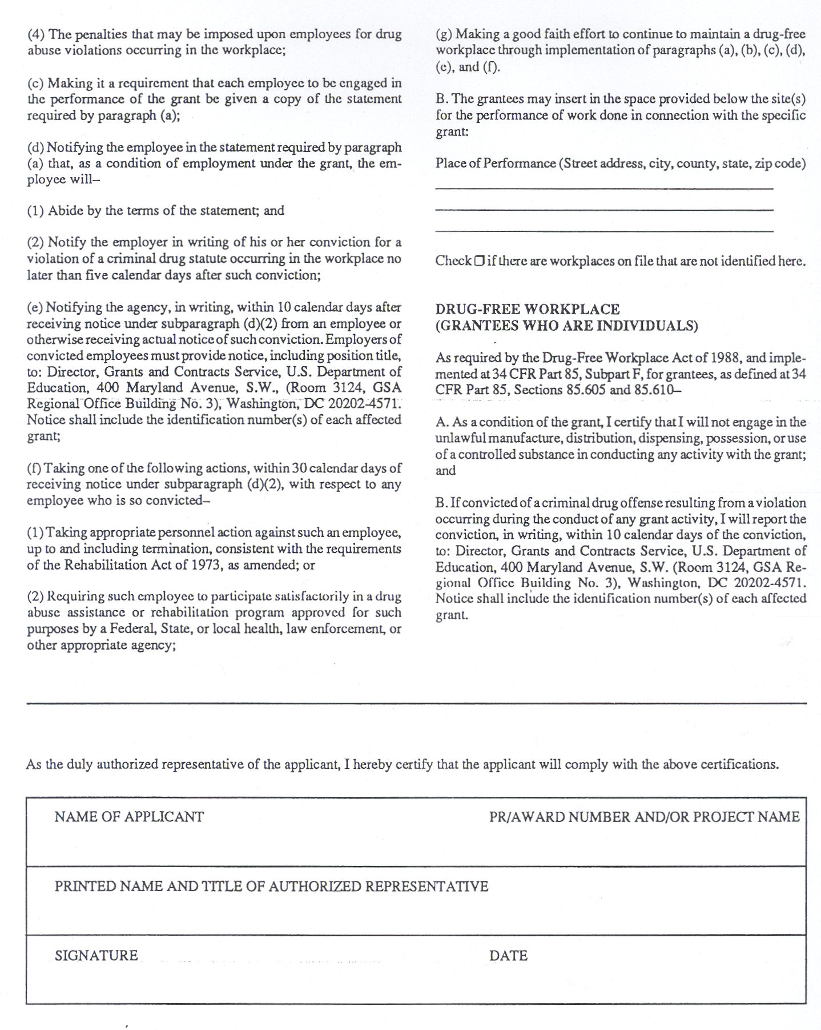

Part II (a)

INSTITUTIONAL PROGRAMS OF STUDY INVENTORY
(FY 2015 Career and Technical Education Programs)

Institution: Date:

A requirement of Perkins IV is the development and implementation of “Career and Technical Programs of Study” containing four key elements. Eligible recipients receiving funds under this Act are required to offer these relevant elements in at least one program of study. [Sec. 122(c)(1)(A)]

In the first two columns, list the CIP Code and Program title for CTE programs at your institution which have been approved for Perkins funding and are on file with the Kansas Board of Regents. In the remaining columns, indicate the status of the Program Alignment initiative as well as for each of the federally mandated elements for CTE programs of study with the word that best describes the current program status: “PLANNING” (pre-development stage), “DEVELOPED” (established, not implemented) or “IMPLEMENTED” (program contains element).
KBOR Perkins Approved CTE Programs |  |  | Program of Study Elements
CIP  Code | Program Title | Program Alignment | Current, formalized Secondary/PS Articulation Agreements | Integrated, Aligned, Non-duplicative Sequence of Courses/ Curriculum | Concurrent Enrollment or Dual Credit | Industry Credential, PS certificate or degree awarded

Part II (b)(1)

PERFORMANCE IMPROVEMENT PLAN FOR UNMET 2012-2013 CORE INDICATORS

Step 1: Document Performance Results

Improvement Priority: Core Indicator: _____________ Institution: ________________

Description of Problem:

Step 2: Root Causes |  | Step 3: Select Best Solutions | Step 4: Pilot Test and  Evaluate Solutions | Step 5: Implement  Solutions
Identify Root  Cause | Evaluation  Methods | Strategies and Models | How, where, when to test | How, where, when to implement

Part II (b)(2)

INSTITUTIONAL GOALS FOR FY15 PROGRAM IMPROVEMENT GRANT FUNDS

Step 1: Identify Institutional Goals

The new OMB SuperCircular identifies a number of changes in the way in which federal funds are being regulated and monitored. While compliance has traditionally been the focus of all subgrantees, guidance indicates that going forward, the focus will be on accountability and performance. Therefore, the annual report that the state must submit to US Dept of Ed will require reporting on goals and performance on those goals. As outlined below, each institution will identify goals that your program improvement grant will address. In Step 2, you will briefly outline how you plan to measure your identified goals.

Identify between 3-5 institutional goals that will be met as a result of the use of Carl D. Perkins program improvement federal grant funds.

Examples:
Goal 1. Academic & Technical Activities - Infuse academic skills into technical courses.
Goal 2. Improve, Expand & Modernize Program Activities – Increase student enrollment, completion and placement.
Goal 3. Establish or refine non-discrimination policies/procedures.
Goal 4. Insure all technical programs have industry standard equipment available to train students.
Goal 5. Professional development activities that lead to instructor credentialing, program or curriculum expansion and improvement.

Step 2: Methods of Measurement

Goal Number | Measurement  Method | Intended Outcome | Positive and/or negative factors which may affect intended outcome
(see above)  1. | Link technical content with relevant occupational knowledge/skills based on industry-recognized standards. | Create a rigorous, integrated and aligned curriculum.
2. | Annual evaluation of regional market needs and occupational relevancy | Ensure programs prepare students for high skill, wage or demand occupations | Market needs may change quickly
3. | Attainment of “core indicators of performance” | Redesign programs to enable attainment, make modifications to curriculum or equipment, if needed. Expand/align student services (assessment, counseling, financial aid, job placement.)
4…..

Part II (b)(2)

INSTITUTIONAL GOALS FOR FY15 PROGRAM IMPROVEMENT GRANT FUNDS

Step 1: Identify Institutional Goals

The new OMB SuperCircular identifies a number of changes in the way in which federal funds are being regulated and monitored. While compliance has traditionally been the focus of all subgrantees, guidance indicates that going forward, the focus will be on accountability and performance. Therefore, the annual report that the state must submit to US Dept of Ed will require reporting on goals and performance on those goals. As outlined below, each institution will identify goals that your program improvement grant will address. In Step 2, you will briefly outline how you plan to measure your identified goals.

Identify between 3-5 institutional goals that will be met as a result of the use of Carl D. Perkins program improvement federal grant funds.

Goal 1.
Goal 2.
Goal 3.
Goal 4.
Goal 5.

Step 2: Methods of Measurement

Goal Number | Measurement  Method | Intended Outcome | Positive and/or negative factors which may affect intended outcome

Part II (c)
FY2015 Perkins Program Improvement for: ____________________________________________

PERKINS PROGRAM IMPROVEMENT ACTIVITY AND PROGRESS REPORT
Academic, Career & Technical Activities

Goal 1: To strengthen the academic and technical skills of students by strengthening the academic and technical education components of programs.
[Perkins Act: Sec. 135(b)(1)]
Line #  1 | Description of the Activity | Funding  $
 | Responsibility: Timeline:
 | Evaluation/Measures:
Dec 1
Mar 1
Aug 1

Line #  2 | Description of the Activity | Funding  $
 | Responsibility: Timeline:
 | Evaluation/Measures:
Dec 1
Mar 1
Aug 1
(Use this area to copy and paste more tables if additional line items are needed.)

Total Perkins Funding Requested for Goal 1: $
Part II (c)
FY2015 Perkins Program Improvement for: ____________________________________________
PERKINS PROGRAM IMPROVEMENT ACTIVITY AND PROGRESS REPORT
Articulation/Postsecondary Linkages Activities

Goal 2: To link secondary with postsecondary career and technical education programs and postsecondary career and technical education programs with baccalaureate programs. [Perkins Act: Sec. 135(b)(2)]
Line #  1 | Description of the Activity | Funding  $
 | Responsibility: Timeline:
 | Evaluation/Measures:
Dec 1
Mar 1
Aug 1

Line #  2 | Description of the Activity | Funding  $
 | Responsibility: Timeline:
 | Evaluation/Measures:
Dec 1
Mar 1
Aug 1
(Use this area to copy and paste more tables if additional line items are needed.)

Total Perkins Funding Requested for Goal 2: $
Part II (c)
FY2015 Perkins Program Improvement for: ____________________________________________

PERKINS PROGRAM IMPROVEMENT ACTIVITY AND PROGRESS REPORT
All Aspects of Industry Activities

Goal 3: To provide students with strong experience in and understanding of all aspects of their chosen industry. [Perkins Act: Sec. 135(b)(3)]
Line #  1 | Description of the Activity | Funding  $
 | Responsibility: Timeline:
 | Evaluation/Measures:
Dec 1
Mar 1
Aug 1

Line #  2 | Description of the Activity | Funding  $
 | Responsibility: Timeline:
 | Evaluation/Measures:
Dec 1
Mar 1
Aug 1
(Use this area to copy and paste more tables if additional line items are needed.)
Total Perkins Funding Requested for Goal 3: $
Part II (c)
FY2015 Perkins Program Improvement for: ____________________________________________

PERKINS PROGRAM IMPROVEMENT ACTIVITY AND PROGRESS REPORT
Use of Technology Activities

Goal 4: To develop, improve or expand the use of technology in career and technical education. [Perkins Act: Sec. 135(b)(4)]
Line #  1 | Description of the Activity | Funding  $
 | Responsibility: Timeline:
 | Evaluation/Measures:
Dec 1
Mar 1
Aug 1

Line #  2 | Description of the Activity | Funding  $
 | Responsibility: Timeline:
 | Evaluation/Measures:
Dec 1
Mar 1
Aug 1
(Use this area to copy and paste more tables if additional line items are needed.)
Total Perkins Funding Requested for Goal 4: $
Part II (c)
FY2015 Perkins Program Improvement for: ____________________________________________

PERKINS PROGRAM IMPROVEMENT ACTIVITY AND PROGRESS REPORT
Professional Development Activities

Goal 5: To provide high quality & comprehensive professional development for teachers, counselors and administrators. [Sec 134(b)(4), Sec 135(b)(5)]
Line #  1 | Description of the Activity | Funding  $
 | Responsibility: Timeline:
 | Evaluation/Measures:
Dec 1
Mar 1
Aug 1

Line #  2 | Description of the Activity | Funding  $
 | Responsibility: Timeline:
 | Evaluation/Measures:
Dec 1
Mar 1
Aug 1
(Use this area to copy and paste more tables if additional line items are needed.)
Total Perkins Funding Requested for Goal 5: $
Part II (c)
FY2015 Perkins Program Improvement for: ____________________________________________

PERKINS PROGRAM IMPROVEMENT ACTIVITY AND PROGRESS REPORT
Program Evaluation Activities

Goal 6: To develop & implement evaluations of CTE programs, including how needs of special populations are being met [Sec 135(b)(6)]
Line #  1 | Description of the Activity | Funding  $
 | Responsibility: Timeline:
 | Evaluation/Measures:
Dec 1
Mar 1
Aug 1

Line #  2 | Description of the Activity | Funding  $
 | Responsibility: Timeline:
 | Evaluation/Measures:
Dec 1
Mar 1
Aug 1
(Use this area to copy and paste more tables if additional line items are needed.)
Total Perkins Funding Requested for Goal 6: $
Part II (c)
FY2015 Perkins Program Improvement for: ____________________________________________

PERKINS PROGRAM IMPROVEMENT ACTIVITY AND PROGRESS REPORT
Improve, Expand & Modernize Program Activities

Goal 7: To improve, expand and modernize quality CTE programs. [Perkins Act: Sec. 135(b)(7)]
Line #  1 | Description of the Activity | Funding  $
 | Responsibility: Timeline:
 | Evaluation/Measures:
Dec 1
Mar 1
Aug 1

Line #  2 | Description of the Activity | Funding  $
 | Responsibility: Timeline:
 | Evaluation/Measures:
Dec 1
Mar 1
Aug 1
(Use this area to copy and paste more tables if additional line items are needed.)
Total Perkins Funding Requested for Goal 7: $
Part II (c)
FY2015 Perkins Program Improvement for: ____________________________________________

PERKINS PROGRAM IMPROVEMENT ACTIVITY AND PROGRESS REPORT
Sufficient Size, Scope & Quality Activities

Goal 8: To provide services & activities that are of sufficient size, scope and quality to be effective.. [Perkins Act: Sec. 135(b)(8)]
Line #  1 | Description of the Activity | Funding  $
 | Responsibility: Timeline:
 | Evaluation/Measures:
Dec 1
Mar 1
Aug 1

Line #  2 | Description of the Activity | Funding  $
 | Responsibility: Timeline:
 | Evaluation/Measures:
Dec 1
Mar 1
Aug 1
(Use this area to copy and paste more tables if additional line items are needed.)
Total Perkins Funding Requested for Goal 8: $
Part II (c)
FY2015 Perkins Program Improvement for: ____________________________________________

PERKINS PROGRAM IMPROVEMENT ACTIVITY AND PROGRESS REPORT
Special Populations Activities

Goal 9: To provide activities to prepare special populations students for high-skill, high-wage, or high-demand occupations that will lead to self-sufficiency.
[Perkins Act: Sec. 135(b)(9)]
Line #  1 | Description of the Activity | Funding  $
 | Responsibility: Timeline:
 | Evaluation/Measures:
Dec 1
Mar 1
Aug 1

Line #  2 | Description of the Activity | Funding  $
 | Responsibility: Timeline:
 | Evaluation/Measures:
Dec 1
Mar 1
Aug 1
(Use this area to copy and paste more tables if additional line items are needed.)
Total Perkins Funding Requested for Goal 9: $
Part II (c)
FY2015 Perkins Program Improvement for: ____________________________________________

PERKINS PROGRAM IMPROVEMENT ACTIVITY AND PROGRESS REPORT
Administration

Goal 10: To provide support for the administration of the Program Improvement grant funds (maximum of 5%)
Line #  1 | Description of the Activity | Funding  $
 | Responsibility: Timeline:
 | Evaluation/Measures:
Dec 1
Mar 1
Aug 1
(Use this area to copy and paste more tables if additional line items are needed.)

Total Perkins Funding Requested for Goal 10: $
PN561.04.2011.9576A

