PSU Literacy Center for Excellence

Vision

The PSU Literacy Center for Excellence [PSU Center] aligns with the Kansas Blueprint for Literacy and is focused on two essential goals:

- Prepare teacher candidates with evidenced-based approaches
- Support in-service teachers with evidence-based approaches

These goals will be achieved through strict adherence to the five core components – phonemic awareness, phonics, fluency, vocabulary, and comprehension – that are rooted in the Science of Reading and Structured Literacy research and practice. Our teacher preparation programs, community outreach, and ongoing professional programs/support will similarly be guided by these five components and aligned with evidence-based instructional practices: instructional hours, background materials, objective measures of knowledge, and opportunities to practice.

To ensure alignment with the Kansas Blueprint for Literacy, the PSU Center will deliver a “…world-class education, and educator training in the Science of Reading ensuring that Kansas teachers and school leaders are highly skilled in the application of the Science of Reading.” Our purpose and mission at Pittsburg State University is to make life better through education. Literacy is the critical building block and foundation of education. We are designing the PSU Literacy Center for Excellence with this compelling vision in mind: To support families, students, educators, and educational leaders using an array of evidence-based and community-based interventions specifically tailored to address the unique needs of our catchment area.

Our overall approach as a Center is founded on the strength of our existing, expanded, and new collaborations with area school districts and community colleges. We are also developing deeper connections in the catchment area with education service centers, such as Greenbush (Girard location) and the Family Resource Center. As we explain in detail throughout this proposal, our plans include the enhancement of pre-service educator preparation, in-service educator programming, district programs/support, and family/adult community outreach. Additionally, we are strengthening and expanding our innovative practices to achieve positive impacts on PK-12 student learning. To achieve these goals, we will incorporate enriching learning activities such as simulation classrooms, experiential trainings, and hands-on opportunities for the area students and educators at all levels of experience [pre-service to in-service].

The PSU Center is committed to meeting the needs of the entire catchment area by leveraging existing campus resources and faculty expertise, as well. For example, the Center for READing (Research, Evaluation, and Awareness of Dyslexia), led by Dr. David Hurford, has been an instrumental partner along with the Psychology and Counseling Department, within our College of Education. Dr. Hurford’s experience and contributions to scientific research on reading acquisition, reading interventions, and reading strategies for struggling students, are founded on the core components of the Science of Reading. As a long-standing (established in 1996) partner to in-service educators, families of struggling readers, and pre-service teachers, Dr. Hurford and the Center for READing trained reading specialists have been supporting literacy for all students, including high-risk learners across the state of Kansas, the United States, and internationally (e.g. Switzerland, Australia, Nigeria, and others).

As we contemplate the monumental task ahead and strive to be good partners to the communities around us, the PSU Literacy Center for Excellence is keenly focused on setting a clear vision, communicating that vision, and working collaboratively with our local and statewide existing partners. We are also seeking new partners and strengthening existing connections so that we are truly leveraging all possible resources to help every child learn to read, to fully support the literacy goals of families and adults, and to set a path forward that recognizes and supports all individuals and organizations which are critical to our mission accomplishment. These partnerships include our families, school districts and leaders, community colleges, and all education professionals, paraprofessionals, ESOL, special education, and reading specialists. Through an array of services provided virtually, on-site, and in our soon-to-be-completed laboratory and simulation classroom, we will deliver coaching, professional development, and training to build knowledge and the ability to apply targeted literacy practices based on the science of reading.

Pre-Service Educator Preparation

Current Programs

Pittsburg State has three paths to initial teaching license in Elementary Education:

- Elementary Education PK-6 is a general classroom teacher license (120 credit hours, 12 hours of special education coursework). This program has new KSDE standards, and our program has already made the changes to be compliant with the new standards in the 2024 catalog.
- Elementary Education Unified PK-6 is a general classroom and high-incidence special education license (125 credit hours, 17 hours of special education coursework) PSU was the first in the state to have this program in 2017-18.
- MAT Elementary Education K-6 is a master's level program that leads to the general classroom teacher license (30 hours, 18-month accelerated program, can be hired by PK-12 schools to be a teacher of record for the last year of the program).

All pre-service teachers are currently being trained in the Science of Reading and Structured Literacy in the newly created Science of Reading I [EDUC 366] and Science of Reading II [EDUC 367]. These two courses provide experiential opportunities to acquire, develop, and practice the fundamental skills that are foundational to implementation of structured literacy in the classroom.

Elementary Education majors at Pittsburg State are in field experiences five of eight semesters for PK-6 and six of eight semesters for PK-6 Unified, beginning with a general education observation in their freshman year (EDUC 261 Explorations in Education). In their sophomore year, candidates do a project where they work with a student designated as "at risk" in a one-on-one experience (SPED 510 Overview of Inclusive Education). In their junior year, first semester, PK-6 Unified candidates engage in a practice-based experience and collaborative learning opportunity with special education stakeholders in the field (SPED 514 Professional Collaboration). Also in their junior year, second semester, all candidates complete Science of Reading I (EDUC 366 Science of Reading I) with a specific structured experience described below and an additional Clinical Experience (EDUC 307 Clinical Experience) where they work in a general education classroom to prepare and teach two lessons. In their senior year, first semester, all candidates complete an internship experience, which emphasizes coursework applications and assesses their ability to implement the science of reading principles and elements (EDUC 367 Science of Reading II). Additional details about this critical internship experience are described below. Lastly, in their senior year, second semester, all candidates complete student teaching (16+ weeks / 560+ hours) in a PK-6 classroom, and unified candidates split their time between regular education and special education classrooms.

In EDUC 366 Science of Reading I, (junior year second semester, Professional Block 2) teacher candidates are paired with K-2 elementary students who are identified as struggling readers, in a local elementary school. The candidates construct a data-driven Reading Assessment Profile on their student, including Phonemic Awareness Assessment data, Letter Name Assessment data, Letter Sound Assessment data, Phonics Assessment data, High-Frequency Word Reading data, Reading Habits, and Reading Interests. Candidates then take this profile data and create recommendations for the student including the claim, evidence, and reasoning for the recommendations. Find attached a copy of the EDUC 366 Practicum Reading Profile Assessment and Analysis student instructions. (This is an assessment we use with KSDE to show that we meet elementary reading and science of reading standards).

In EDUC 367 Science of Reading II, (senior year first semester, Internship Block) teacher candidates partner with the Center for READing at PSU to observe and assist in interventions (See attached Center for READing Practicum). Additionally, in their field placement for an internship, candidates complete a Guided Inquiry on Structured Literacy that includes researching the question: How does structured literacy meet the learning needs of diverse learners?; Analyzing the district-purchased ELA curriculum for elements of Structured Literacy at their internship site; conducting an interview with their cooperating teacher; creating a Structured Literacy Lesson Plan; and teaching a structured literacy lesson reflecting on teaching (See Attached Module 2 Guided Inquiry Project on Structured Literacy Student Instructions).

We are in the process of hiring one of two new faculty members with demonstrated structured literacy experience and expertise in the Science of Reading In our first literacy expert search for a new faculty member, the pool of applicants is promising, and we will soon expand our efforts to begin searching for a second faculty member with a similar solid foundation in the Science of Reading and Structured Literacy.

Success of Program Completers on Licensure Exam

The College of Education teacher education programs are always in continuous improvement and growth mindset thinking. Data is reviewed annually by coordinating councils and external advisory groups to drive our continuous improvement efforts. For elementary education programs there is an Elementary Education Coordinating Council (EECC) that oversees changes to the program specifically and has input into teacher education unit decisions such as alignment of admission checkpoints, student teaching, governing policies, etc. The elementary program faculty also meet monthly to discuss program changes, course revisions, student issues, and interventions. The EECC and program faculty groups examine data annually for the programs and make recommendations based on that data. Data that is reviewed by this group includes Praxis exam scores and sub-scores, first- and third-year completer follow-up data which includes employer satisfaction and program quality data.

The College of Education has created a student advisory council. Student members meet on a monthly basis to share and discuss student concerns, review program retention and achievement data, receive detailed information about potential changes to degree requirements and foster open communication between students and faculty members. Students and faculty have found this advisory board to be constructive and a positive extension of the mentoring role of the education profession. Topics shared with the advisory board include the many impacts regional poverty has on PK-12 learning, PSU College of Education enrollment trends, and Praxis pass rates.

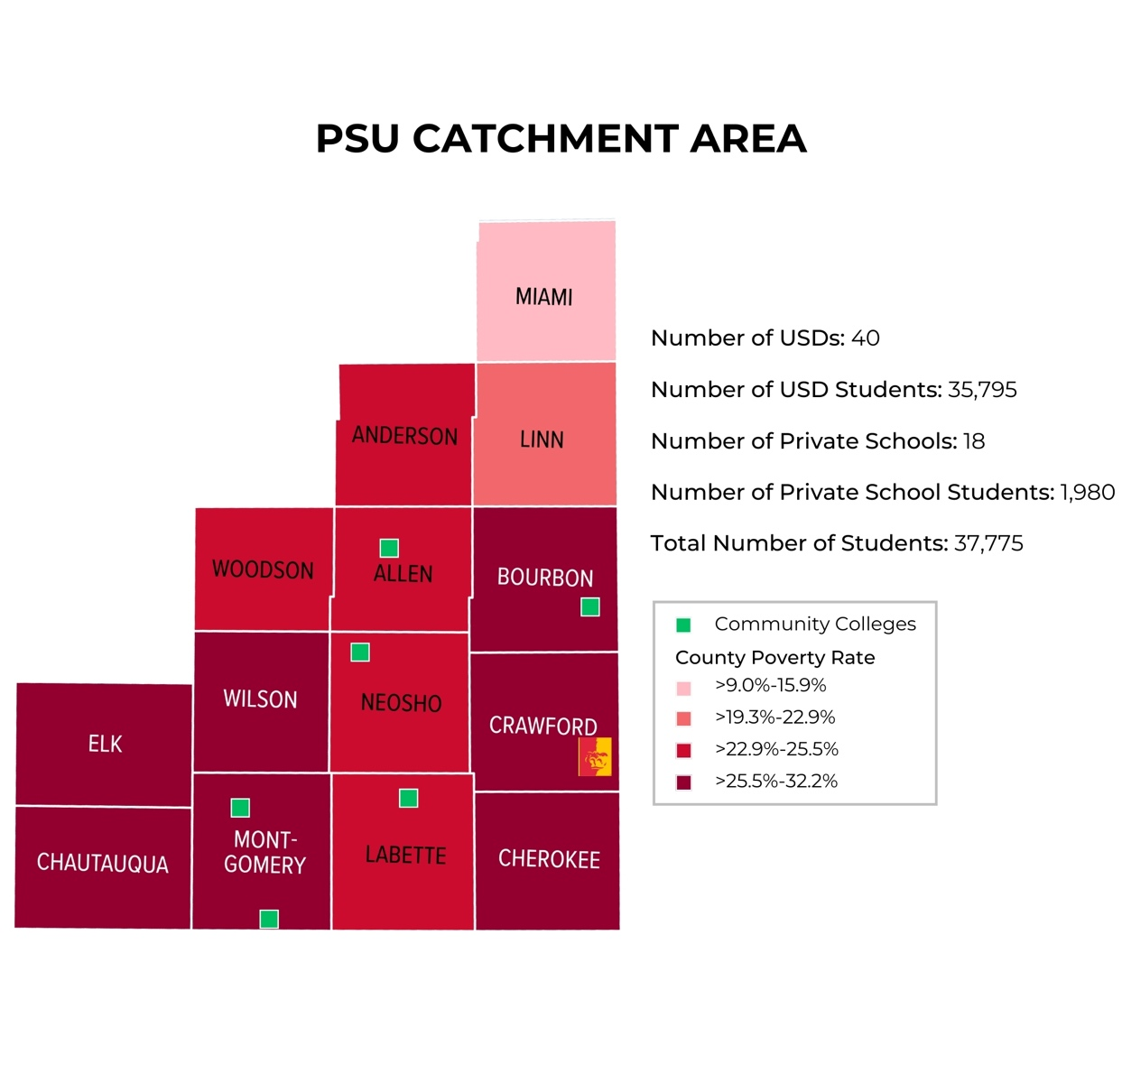

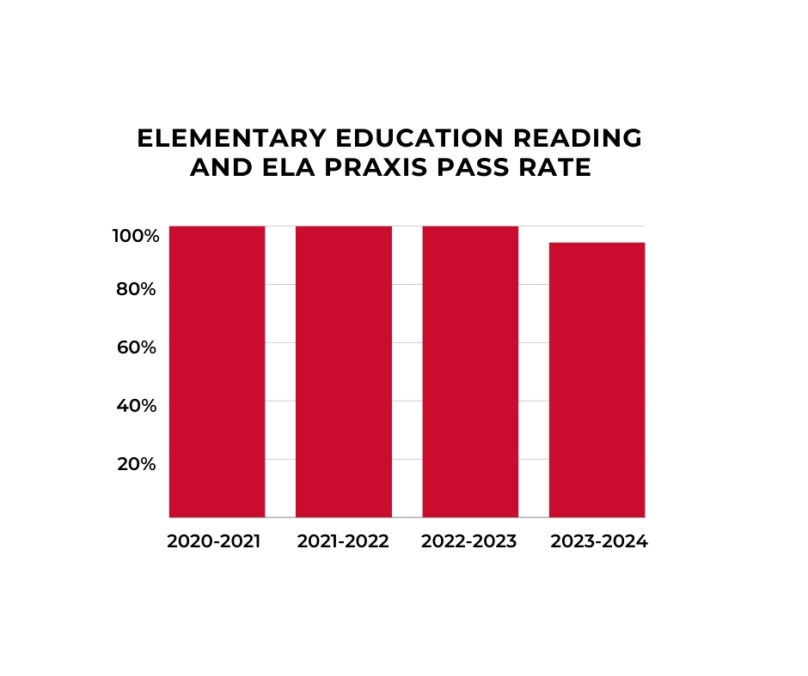
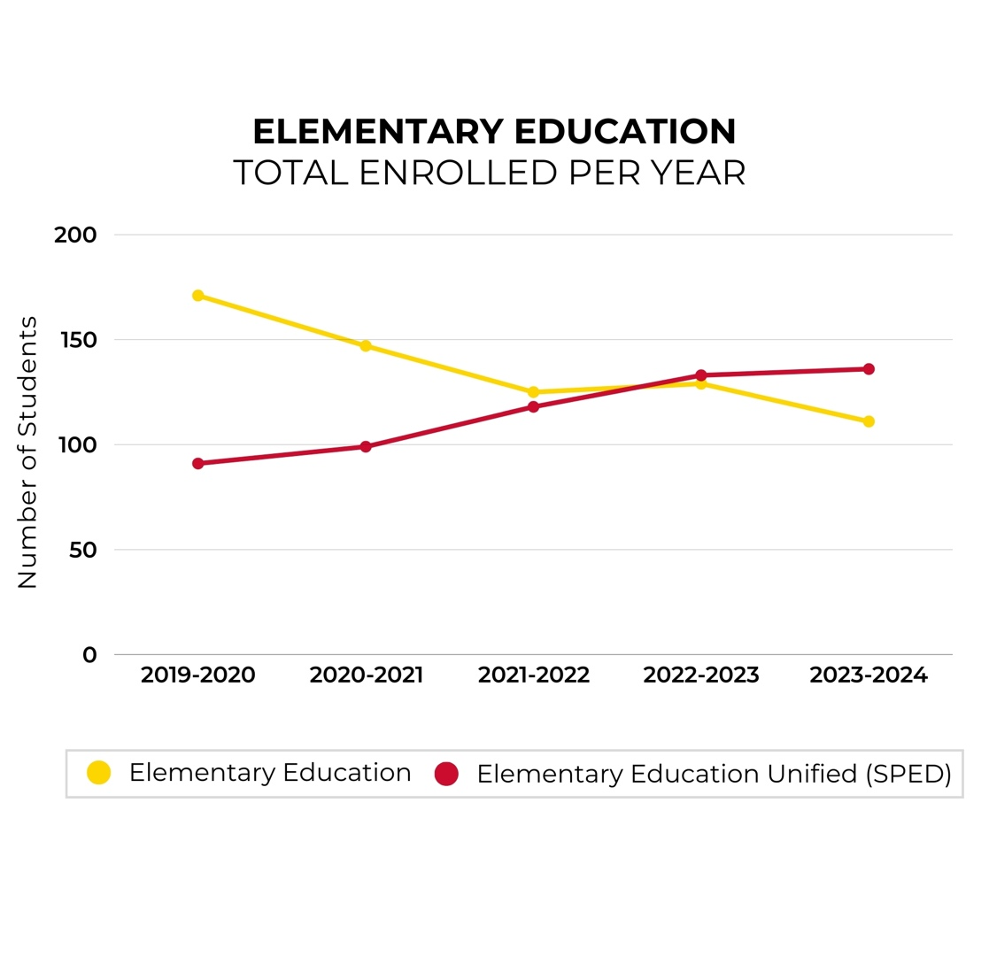
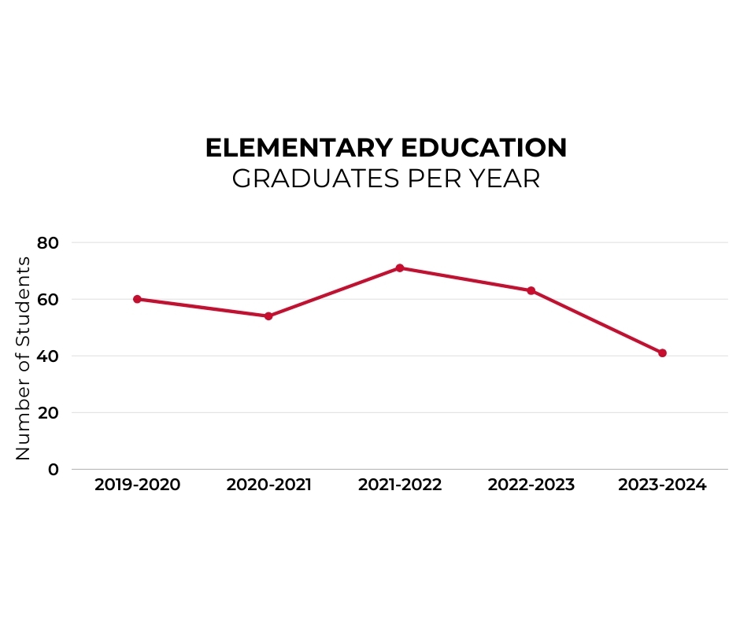
Proposed Enhancements

We will be incorporating an array of innovative initiatives to enhance our current PK-6 pre-service teacher preparation program. These initiatives include the simulation activities and classroom laboratory experiences described below. In addition to these new simulation and laboratory classroom experiences, we will improve assessment efforts by incorporating frequent evaluations of our current practices.

Using evaluation protocols, we will assess all syllabi, textbooks, and course content including lecture notes and PowerPoint presentations in all courses to ensure alignment and improve as needed the literacy instruction for both the undergraduate and graduate levels. These course evaluation initiatives will also be used to promote and assess alignment with the International Dyslexia Association (IDA), Knowledge and Practice Standards (KPS), Kansas Educator Preparation Provider Accreditation and Program Standards for Elementary Education, and the provisions of the Kansas Blueprint for Literacy (i.e., that the use or teaching of any discredited methodologies, such as the three-cueing system, are prohibited).

Along with a laboratory classroom within the PSU Center of Excellence, we will also be creating a simulation classroom to be located within Hughes Hall on the campus of Pittsburg State University. Hughes Hall houses our College of Education and our Teaching and Leadership Department and is the location for most of our teacher education courses. This classroom will be designed to allow our teacher candidates the opportunity to practice the art of teaching in a safe environment. It is designed for the continual improvement of our teacher candidates, similar to the established learning simulations that are essential to our school of nursing students

The simulation classroom will replicate a modern classroom and will include an interactive board, flexible seating, triangle desks, whiteboards around the room, tablets synced to the interactive board, a mobile teacher podium, magnetic whiteboards, a kidney table, a document camera, and recording technology. This simulation classroom can be used by our students, whether their career goal is to teach high school math or elementary special education, to practice executing their lesson plans, hone the skill of shifting proximity within the classroom, and interacting with technology. This room will be utilized in conjunction with our Instructional Resource Center, also housed in Hughes Hall, where many manipulatives and teaching resources are available to be checked out.

This classroom will always have video capabilities for students to utilize. The goal of the classroom is not only to be utilized during specific course sessions but also as a practice space for pre-service teachers preparing and delivering lessons. This room will not only benefit our elementary education teacher but can also be utilized by our secondary education candidates.

Pre-Service Simulations

To expand on the courses [EDUC 366 & EDUC 367] and in-field experiences for teacher candidates described earlier for teacher candidates, an educational learning simulation and classroom laboratory opportunity will be developed for pre-service teachers to apply their literacy knowledge under close supervision, we plan to capture real-time videos of students who are struggling with literacy and receiving evidence-based instruction and literacy interventions by our faculty, Center for READing staff, or in-service educators. This learning simulation will provide the students with a simulated experience and opportunity to assess the student and analyze the instructional strategy and literacy interventions. During this initial phase of the simulation, students will be provided with scaffolded support and will work collaboratively with their peers and faculty members or Center for READing staff to identify the appropriate literacy instruction strategies to positively impact students’ learning experiences. This simulation exercise is a necessary first step to build self-efficacy regarding the implementation of literacy instructional strategies. It is necessary to enhance pre-service teachers’ practical skills and then further hone their skills in the classroom laboratory environment, which is the second step and expanded component of the simulation exercise.

As students become more confident and competent in their science of reading and structured literacy skills, the scaffolded support introduced in the simulation learning activities will be reduced systematically. This will enable the pre-service teachers to become increasingly comfortable with independently implementing Science of Reading and Structured Literacy strategies. The classroom laboratory will be incorporated into the current plans that are in progress for PSU’s Gorilla Rising initiative that started in 2022. As part of this overall initiative, the Center for READing and PSU’s new Literacy Center for Excellence will be moving to downtown Pittsburg, in the historic Besse Hotel.

This downtown location will provide a welcoming and easier to navigate location, easing the complications associated with accessing a college campus, such as parking, navigating buildings, and general discomfort that some families and even educators may experience due to the stigmas that are sometimes attributed to higher education campuses. Thus, we believe the PSU Literacy Center for Excellence ensures The Center will be easier for school districts, classroom educators, parents, and families to physically access. Additionally, the PSU Literacy Center for Excellence will utilize, expand upon, and fold in the services and activities that the Center for READing has been providing for nearly 30 years.

In-Service Educator & District Programs/Support

Current Programs

The Master of Science in Reading program has undergone major revisions between Spring 2022 and Fall 2024. During this time, the college of education faculty, leadership team, and school district partners worked collaboratively to align the MS Reading program with the Knowledge and Practice Standards for Teachers of Reading, the International Dyslexia Association (IDA) core principles, and the recently revised KSDE Standards. Once we completed the process of aligning our courses with these standards and principles, we examined our course objectives to ensure they were similarly aligned and grounded in the Science of Reading and Structured Literacy. All course content across the MS Reading program was further revised to support three levels of knowledge: declarative, procedural, and decisional, to prepare candidates for assessment and instruction of Structured Literacy in both classroom and intervention settings.

The MS Reading program course sequence begins with a foundations course, which introduces Science of Reading research and theories. Then, in two developmental literacy and instruction courses, students analyze reading and writing acquisition in the context of Scarborough’s Reading Rope and key Science of Reading models learned in the foundations course. In these courses, reading candidates apply their understanding of the processes of reading and writing to identify appropriate Structured Literacy instructional components. In future course development, these two courses are proposed to be renamed Advanced Science of Reading I and Advanced Science of Reading II, to be consistent with the seamless transition from the undergraduate to graduate reading courses.

The progression of courses in the Master of Science in Reading program continues to support the Knowledge and Practice Standards (IDA) and KSDE Standards. The culmination of the program are two practicums, in which reading specialist candidates administer Structured Literacy assessments, analyze data to plan for and implement Structured Literacy interventions, and analyze the impact of instruction through progress monitoring.

In-Service Simulations

Through ongoing partnerships with regional school systems, in-service teachers will have access to the educational learning simulation classroom laboratory, allowing them the opportunity to apply their literacy knowledge with support from our literacy experts [new and existing faculty members], Center for READing staff, and science of reading professionals. Modeling opportunities and supervision will be provided and systematically reduced as teachers become increasingly competent at independently implementing the Science of Reading and Structured Literacy strategies.

As part of PSU’s Literacy Center for Excellence, the newly developed laboratory classroom will be accessible to our catchment area school districts and educational professionals. The laboratory classroom will provide opportunities for pre-service and in-service teachers to observe and practice implementing the Science of Reading. The laboratory classroom will have the capability for people to view instructional practices from behind a one-way window. This laboratory classroom will utilize real classes from local elementary schools. In-service elementary classroom teachers will provide instruction to their class inside the laboratory classroom. Pre-service teachers will observe and engage in a continual dialogue with literacy coaches throughout the class session. Classroom sessions will be recorded for discussion with the classroom teacher as they continue to grow in their teaching practice and the engagement of students in the science of reading. The opportunities for pilot schools to utilize the laboratory classroom have been arranged through partnerships with local school districts.

Classroom teachers often want help with their specific class. The laboratory classroom allows the classroom teacher the opportunity to work with their class and the specific needs of their students. It allows a real-world opportunity that is relevant to the classroom teacher and their continued growth and to the preservice teachers and their training. Literacy coaches will be utilized to continue to work with classroom teachers throughout the school year. Classroom teachers will be asked to bring their students back at multiple points throughout the year to track progress and provide opportunities for observation.

Coaching

In focus groups conducted with area superintendents, a near unanimous request was made for trained literacy coaches to assist in-service teachers in their classrooms and buildings. They felt this, along with continuing professional development, would have a great impact on methods of instruction that best serve the needs of all students. On-going, immediate feedback would be the hallmark of this service. The coaches, in turn, would help train any staff members who would serve their colleagues, focusing on early-career teachers.

The Kansas Department of Education [KSDE] has provided policy guidance, requiring school districts to require annual professional development on structured literacy and/or dyslexia. Professional learning is required annually; however, each school district is allowed to determine the time and duration of the training. According to the parameters established by KSDE, the training should be hands-on, with evidence-based practices, on the nature of dyslexia, and include procedures to identify students who are struggling in reading, intervention strategies and procedures, tiered intervention practices, or progress monitoring. The training can be held during consecutive Professional Learning Communities (PLC) meetings and does not require a dedicated professional development day. The following professionals are required to obtain this annual training:

- All teachers endorsed elementary education.
- All teachers endorsed early childhood unified.
- All teachers endorsed high-incidence special education in teaching in grades PK-12.
- All teachers endorsed English Language Arts grades 5-12.
- All teachers endorsed as reading specialists.
- All professionals endorsed as school psychologists.
- Highly recommended that paraeducators receive the training.

Our plan is to collaborate with school districts in fulfillment of the KSDE policy and to offer support through the PSU Literacy Center for Excellence. As we described above, we will employ simulation and the newly developed laboratory classroom to ensure access and enriching coaching opportunities for school districts and educational professionals in our catchment area.

Center for Excellence Pilot Program

To achieve maximum effectiveness in establishing the new Center for Excellence in Literacy it has been established that a pilot program involving three area school districts receiving targeted services would give the Center an opportunity to observe the initial impact the Center would have on reading scores in the selected districts.

After an agreement is reached between the school district and the Center an initial assessment would be given to the teachers and administrators of the selected schools to determine the extent structured literacy has in the current third grade curriculum and the training and support of the staff at that grade level. Once this has been gathered, an in-person discussion would take place with the appropriate stakeholders of both the school and the Center to give an overview of the potential services and answer any questions the building staff may have. There would also be a collection of staff data pertaining to professional development in the area of structured literacy as well as the work and educational experience of the targeted classrooms.

Clear and informative communication would then be sent home to the students being served giving an opportunity for parents to ask questions and be interactive partners in their child’s developing reading skills.

Data such as state assessments in English-Language Arts both current and historical would be evaluated. In addition, any other standardized testing in the area of reading would also be collected. An assessment of current MTSS (Multi-tiered Systems of Support) practices and structures would be observed and evaluated with findings shared with the staff. Once this data has been collected and analyzed in total, the findings would then be reported to the building staff along with suggestions for services in areas commonly identified in need of support.

Both on-site and virtual professional development would take place which would include significant time spent on literacy coaching and use of simulated classroom environments.
A key component of the pilot would be the establishment of trust, both personally and professionally with the school staff and Center. Progress monitoring would be more frequent along with periodic adjustments to the instructional program where needed.

Assessment & Evaluation Services

The Center for READing has a long history of providing evaluation and intervention services for students experiencing challenges with reading and literacy. These services will continue and expand to support our achievement of the vision that is central to PSU’s Literacy Center for Excellence. Pre-service teachers will be provided the opportunity to observe the evaluation process, be trained in screening and evaluation tools, and practice using them so that they are prepared to administer these tools and tools like them. Students will receive training in how to interpret the screening and evaluation data and use it appropriately so that students can receive adequate instruction and intervention. For decades, undergraduate students, graduate students, and others have had the opportunity to be trained in the Center for READing intervention strategies and become interventionists to provide direct services to struggling readers, and this will continue to be offered as an option for additional applied practice.

The Center for READing offers intensive week-long interventions in which families visit the center for a week and the person receives a condensed and intensive intervention protocol all day for five days. The intensive week-long intervention is followed up with online or in-person weekly intervention services depending on the family’s location and distance from Pittsburg State University.

Outreach (Partnerships & Families)

Existing Partnerships

- Southeast Kansas Interlocal 637 – a cooperative agency that provides special education services to thirteen school districts within Southeast Kansas. Developing a strong relationship with this organization will help those who are providing services to struggling readers understand the nature of reading failure, and strategies for screening, evaluation, and intervention services for those thirteen school districts.
- Service Centers – Greenbush is the service center within PSU’s catchment area. Contacts have been made to further develop the training that they are providing in Structured Literacy and their potential contributions to the micro-credential.
- Project Head Start – The Center has a working relationship with Project Head Start and will be providing screening and intervention services to Head Start programs within PSU’s catchment area.

- Diocese of Wichita Catholic Schools
- Phillips Fundamental Learning Center
- SEK Big Brothers Big Sisters
- Crawford County Mental Health
- Family Resource Center
- Kansas Literacy Coalition – Reading League KS and Decoding Dyslexia KS
- International Dyslexia Association – KS/MO
- FHSU Language and Literacy Institute

Community Colleges. We have previously established 2+2 agreements in place between PSU and three community colleges in our catchment area. We have initiated new collaboration discussions and will explore goals of expanding our collaboration and literacy training/support goals with new Community College partners, including Neosho, Labette, and Allen. Our plan is to expand our impact through collaboration with our community college partners and provide opportunities for their faculty and students to interact with the PSU Literacy Center for Excellence in several ways. Students who are working toward an associate’s degree in psychology, education, or a related field will be provided with the opportunity to become interventionists using the strategies already used at the Center. The intention would be for the community college students to become proficient in those strategies and then be deployed in the surrounding school system to provide in-person intervention sessions to struggling students. These efforts will not only help students in public education but will likely provide the impetus for community college students to complete their bachelor’s degree at PSU, preferably seeking training that results in a teacher’s license, or graduate training in school psychology or school counseling. With the current shortage of teachers, school counselors, and school psychologists in our state, efforts to develop the workforce in these areas would be very helpful to Kansas’s public schools.

Future Partnerships

Since the passage of the Literacy legislation, PSU staff have met on a regular basis with groups of superintendents from our catchment area. While helping foster a better understanding of the legislation requirements, we have listened to the “asks” of this group of education leaders. They want to collaborate in ways that will lead to strengthening the success of newly hired teachers. They would like College of Education professors to coordinate ongoing mentoring during the first two years of an in-service educator’s employment with the district. Planning has begun to coordinate this process with school districts.

Because most of the 18 private schools in our catchment area do not offer high school level courses, we know that these students will likely matriculate to public school districts. We will continue to reach out to the leaders of these schools to schedule screening services for the nearly 2,000 students attending private schools and in-service teacher coaching.

Aside from growing our partnerships with community colleges, as presented in the prior page, College of Education leaders from K-State and Washburn have reached out to Dr. Hurford and Dr. Bon with requests for collaboration with determining appropriate assessments for their Center and for implementing a Lab School program. PSU leaders believe that developing shared goals and data collection within partnering institutions has the potential for broadening the positive impact we can have on pre- and in-service educators and Kansas families.

Current & Planned Student/Family Support

The outreach focus of PSU is currently achieved through an array of school district partnerships across Kansas. In particular, these school district partners are essential supporters of our pre-service teachers who engage in multiple internship experiences as they hone their instructional skills and practice as future educators. We seek to expand upon these positive relationships and incorporate intentional practices that restate our commitment to support the partnering school districts from our catchment area, specifically with respect to our efforts focused on enhancing structured literacy practices and supporting the science of reading strategies in the school district. Parental outreach and student support will also be critical components of our intentional expansion efforts. We believe through these efforts; we will be able to strengthen our existing partnerships and find multiple opportunities to engage deliberately around literacy initiatives in these school districts.

Our critical existing campus partner, the long-standing PSU Center for READing has been providing families with support through consultation services and parent training opportunities to empower and equip families with the knowledge, tools, and guidance necessary to become their child’s best advocate. Support through consultation services offers families an understanding of reading difficulties, the evaluation and intervention process, and navigating the school-based systems of support such as MTSS and special education. Consultation services often include collaboration with the district-based team to help build an effective system of support. Parent training opportunities through coffee chats, webinars, and conferences offer an understanding and the tools necessary to effectively navigate reading difficulties, dyslexia, and the evaluation and intervention process. School-based systems provide added support such as MTSS and special education, building parent-teacher partnerships, building student advocacy skills, and the social and emotional impact on the family.

The Center for READing team currently providing family support services and consultation consists of the Director, Director of Evaluation, Director of Intervention, and acting Director of Education and Outreach. To further develop the family support through parent-training opportunities the Director of Education and Outreach position will need to become a permanent position.

Additionally, the Center for READing has been offering evaluation and intervention services for adults for the past three decades. These services have not been marketed or advertised historically, due in part to capacity issues, thus few parents and families knew about or benefited from services available at the Center for READing. The catchment area school districts, parents, families, and community members will be made aware of the adult literacy services that are available. We believe an expansion of the existing adult literacy services is possible in collaboration with the Community Colleges in our catchment area. Community Colleges have historically been leaders in adult basic education. Screening and interventionist training could bolster our efforts to provide additional strength within our region by responding to the literacy needs of everyone in our communities.

Lastly, The Center for READing staff has offered the Secret Codes Camp, an eight-week transformative summer program designed to enhance reading skills and prevent reading failure. The camp has been open to all children who want to get a jump start on learning to read or who are struggling to learn to read. With a more robust relationship with our school districts, additional families would benefit from knowing about the availability of in-person and virtual Secret Codes Camp.

Personnel Capacity & Qualifications

As described briefly above, the Center for READing at Pittsburg State University is an essential partner that significantly contributes to our capacity and qualifications to support current programs and initiatives. The Center for READing was established in January 1996 with the vision of helping as many individuals as possible to become competent readers. Its mission is to prevent and remediate reading disabilities and research and test strategies that lead to the improvement of remedial processes. Further, it is the mission of the Center for READing to provide educators and parents with interventions and knowledge about reading/learning disabilities and provide comprehensive evaluations of readers of all ages. Education for the general public about issues pertaining to reading, reading failure, dyslexia, and attentional difficulties such as ADHD is also offered by the Center. This education has included in-service training and presentations at local, state, regional, national, and international conferences. The Center for READing has a long-ranging reputation assisting families in Kansas, across the United States, and internationally (e.g., Switzerland, Australia, Nigeria, and more).

Over 12,000 children, adolescents, and adults have received in-person reading intervention since 1996, and intervention support has also been provided online since 2014. In addition, educators from public and private schools in Kansas have collaborated with staff from the Center to help shape appropriate strategies and interventions for struggling students and engage in professional learning opportunities. The Center for READing staff has also contributed to helping develop effective IEPs and 504 Plans when asked by the school system or the parent.

Using MTSS definitions, the curricula has been developed for use in Tier 1 student classrooms (the setting for all students in a regular education classroom). Curricula and interventions have also been successfully used for Tier 2 students (the small group break-out setting for ‘some’ students, meaning at-risk students receiving additional interventions) and for Tier 3 students (one-on-one setting for the ‘few’ high-risk students using targeted interventions). These curricula and intervention methods continue to be available for school systems to learn to use under guidance from the PSU’s Center for READing staff.

Quality Assurance System

Data Collections & Analysis

The College of Education has an established data collection and analysis system to meet program accreditation requirements. CAEP Accountability Measures Requirements include:
- Measure 1 (Initial): Completer effectiveness. (R4.1) Data must address: (a) completer impact in contributing to P-12 student-learning growth AND(b) completer effectiveness in applying professional knowledge, skills, and dispositions.
- Measure 2 (Initial and Advanced): Satisfaction of employers and stakeholder involvement. (R4.2|R5.3| RA4.1)
Data provided should be collected on employers' satisfaction with program completers.
- Measure 3 (Initial and Advanced): Candidate competency at completion. (R3.3)
Data provided should relate to measures the EPP is using to determine if candidates are meeting program expectations and ready to be recommended for licensure. (E.g.: EPP's Title II report, data that reflect the ability of EPP candidates to meet licensing and state requirements or other measures the EPP uses to determine candidate competency at completion.)
- Measure 4 (Initial and Advanced): Ability of completers to be hired (in positions for which they have prepared.)

The following is a list of the assessment data collection tools that will continue to be used and analyzed by the Center for READing staff and graduate-level evaluators:
- Kindergarten Round-up:
  - Brief Assessment of Reading for Kindergarten (BARK – used for 8 years)

- Center Evaluations:
  - Dyslexia Evaluation Tool (DET)
  - Test of Variables of Attention (T.O.V.A. 9)
  - Behavior Assessment System for Children, Third Edition (BASC-3)
    - Self-Report of Personality (SRP)
    - Parent Rating Scale (PRS)
    - Teacher Rating Scale (TRS)
  - Wechsler Nonverbal Scale of Ability (WNV) -OR- Wechsler Abbreviated Scale of Intelligence, Second Edition (WASI-II)
  - Hearing screening
  - Clinical Interview(s)
    - Examinee
    - Parent/Guardian
- Titration monitoring evaluations:
  - T.O.V.A. 9
  - WNV or WASI-II
  - Clinical Interview(s)

DET is the evaluation tool that Dr. Hurford developed several decades ago. It is the initial evaluation tool, then it is used to track and analyze an individual’s progress. DET will continue to be used frequently (every 2 to 3 sessions) along with a task that evaluates words per minute (WPM) and writing samples. The TOVA is an objective measure of attention and is used to help evaluate for ADHD. The BASC-3 is used to evaluate socio-emotional issues.

As the implementation of our pilot program moves forward, a protocol for collecting and tracking data will be established for the analysis of information. Staff will also meet with district teachers and administrators to help them with data collection and analysis.

Impact Measures

Our approach as a Center is to nurture the ongoing work necessary to strengthen each of our existing, expanded, and new collaborations. Pittsburg State University will use data collected to help quantify the positive impact of this work in areas such as annual state assessment scores, progress in other standardized testing assessments – such as MAP – administered by school districts, and enrollment growth, Praxis pass rates and graduation trends in the College of Education. Recommendations from the CAEP accreditation cycles will also be evaluated.

Personal feedback from those served by our initiatives – our Student Lab Classroom, our Lab School, and our USD Pilots – will also be reviewed, evaluated, and used for further improvement or transformation. The Panorama Surveys will be used for pre-service education students. Email and written surveys will be sent to parents, paraeducators, in-service teachers, and other licensed support personnel such as reading specialists, instruction coaches, school psychologists, building administrators, superintendents, and school board members. Our nonprofit community allies, community college collaborators, and university partners will have opportunities to share their critiques and advice.

